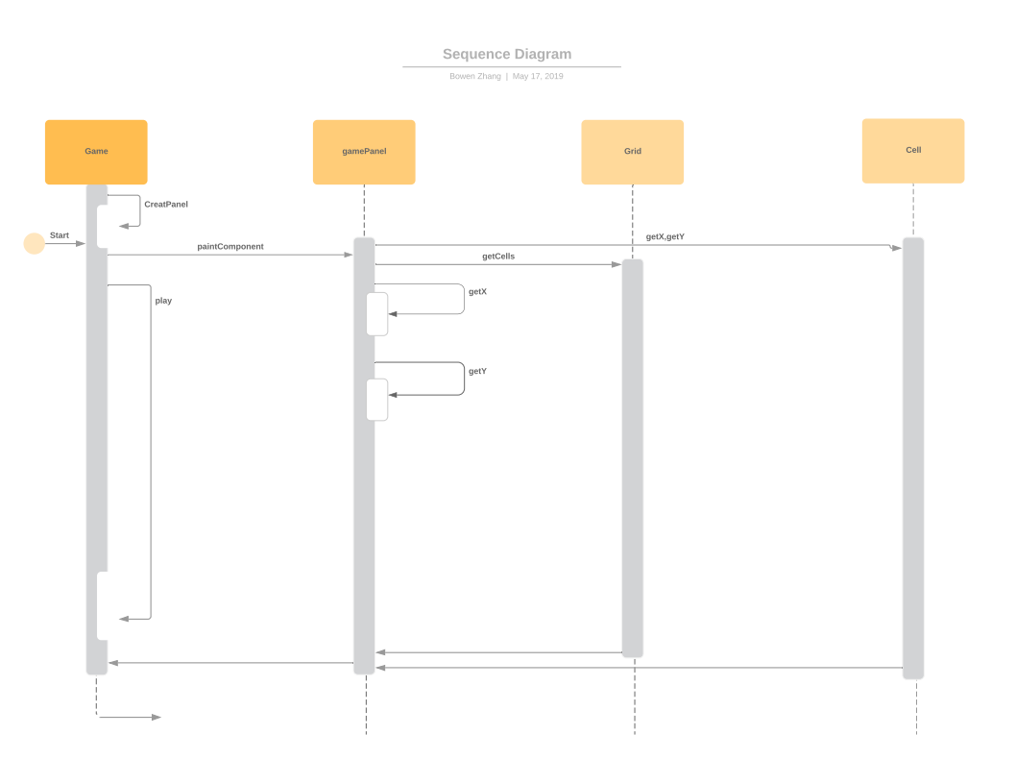

|  |  |
| --- | --- |
| Use Case Name | Start Game |
| Version | 1.0 |
| Goal | Open up the game and running |
| Summary | The player can open the game and start it |
| Actors | player |
| Preconditions | Player are able to open the game frame |
| Triggers | Player press the start button |
| Basic Course of Events | When the game is opened, the programe draw the initial grid on the board |
| Alternative | None |
| Post-conditions | None |
| Business Rules | None |
| Notes | None |
| Author and Date | Bowen Zhang 31/05/2019 |

Activity Diagram:

